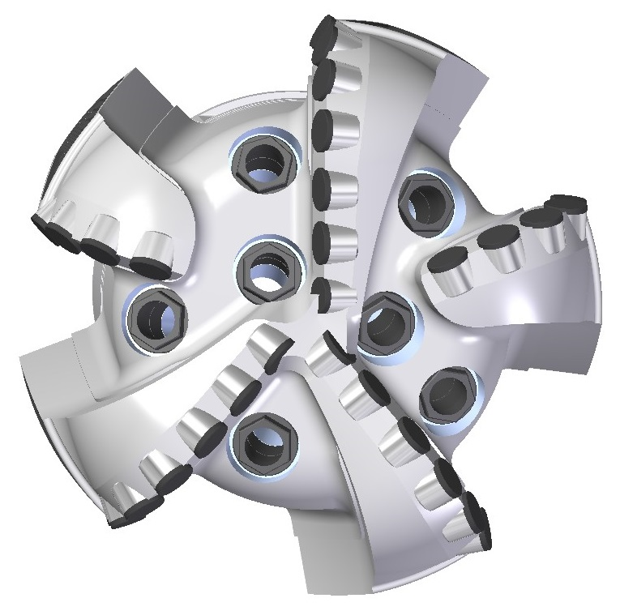 |  | 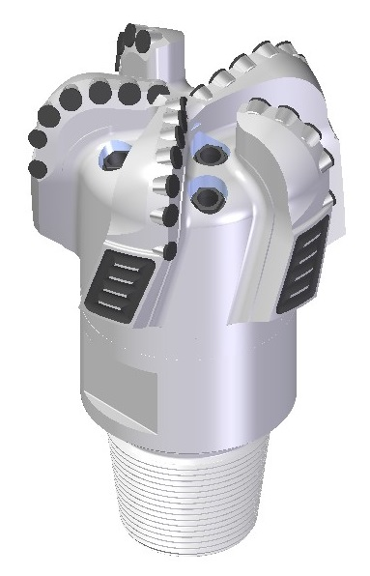

Drill Bit Specifications:
Cutter Size (Primary, Sec) |  | 5/8”, 1/2”
Cutter Count (Total, Gage) |  | 32, 8
Blade Count |  | 5
Gage Length (Inches) |  | 2.50
Nozzle Count (Primary, Sec.) |  | 7
Nozzle Size (Primary, Sec.) |  | 60
JSA (Sq. Inches) |  | 18.40
Max. TFA (Sq. Inches) |  | 2.60
Operating Parameters:
Max. Hydraulic Flow Rate (GPM) |  |  |  | 810
Make-Up Torque (FT-LBS) |  |  |  | 16,500
Max. Weight on Bit (1,000 Lbs.) |  |  |  | 27
Nominal Dimensions:
Overall Length (Inches) | 14.375
Make Up Length (Inches) | 10.25
Bit Breaker | SKB-21010
Connection | Ø4-1/2" API Reg.
Approx. Weight (Lbs.) | 120

Standard Features:

- Large open face volume assists cuttings removal
- Seven nozzles optimize blade cleaning and cuttings removal
- Premium grade cutters maximize ROP and Life

516-SR7 Nomenclature Explained:

- 5 = Number of Blades
- 16 = Primary Cutter Size (16mm)
- SR = Single Row
- 7 = Number of Nozzles
Interchangeable nozzles.

